
TASK 2 REPORT
Requirement Gathering
CEF440: PROGRAMMING AND MOBILE PROGRAMMING

UNIVERSITY OF BUEA

FACULTY OF ENGINEERING AND TECHNOLOGY
(FET)
REPUBLIC OF CAMEROON

PEACE-WORK-FATHERLAND
BUEA, SOUTH WEST REGION

By:
GROUP 4 MEMBERS

COURSE INSTRUCTOR:

DR NKAMENI VALERY

Submitted by group 4

Name | Matricule
AKO JUNIOR NGOH | FE23A008
ETUMA ELKINGS BOSANGO | FE23A053
MOUKAM HAKO BELLAMY STEVE | FE23A096
NJIKANG BRIGHT NDODE NGONE | FE23A115
RINGYUY MBUNWE GIYOH LEMUEL | FE23A136

Table of Contents
Introduction 1
1. STAKEHOLDER IDENTIFICATION 2
1.1 Introduction 2
1.2 Primary Stakeholders 2
1.2.1 Mobile Network Users 2
1.2.2 Telecom Network Operators (e.g., MTN, Orange, CAMTEL) 2
1.2.3 Network Engineers 2
1.3 Secondary Stakeholders 3
1.3.1 Project Developer (System Designer) 3
1.3.2 Supervisors 3
1.3.3 Regulatory Authorities 3
1.4 Stakeholders Summary Table 3
Influence 3
2. REQUIREMENT GATHERING 5
2.1 Overview 5
2.2 Surveys (Questionnaires) 5
2.2.1 Why We Chose Surveys 5
2.2.2 How the Survey Was Designed 5
2.3.3 Survey Overview 6
2.3.4 Key Discovery 6
2.3.5 Interest in Performance Reports 11
2.4 Brainstorming 11
2.4.1 Why We Used Brainstorming 11
2.4.2 How the Sessions Were Conducted 12
2.4.3 Ideas Generated 12
2.5 Reverse Engineering 12
2.5.1 Why We Used Reverse Engineering 12
2.5.2 OpenSignal 13
2.5.5 What Reverse Engineering Taught Us 14
2.6 Summary of All Requirement Gathering Findings 15
3.1 Overview of the Data Gathering Strategy 16
3.2 Primary Data Sources and Collection Methods 16
3.2.3 App Analysis 17
4. DATA CLEANING 19
4.1 Cleaning Process 19
Step 1 – Encoding and Character Artifact Removal 19
Step 2 – Incomplete Response Handling 19
Step 3 – Normalization of Free-Text Fields 19
Step 4 – Duplicate and Timing Check 19
Step 5 – Multi-Select Parsing 19
4.2 Data Cleaning Summary 19
5. USER ASSESSMENT AND USER RELUCTANCE 21
5.1 User Assessment 21
5.2 User Reluctance 21
5.2.1 Key Causes of User Reluctance 21
5.3 List of User Concerns 22
5.4 Primary Reluctance Drivers 23
5.4.1 Privacy Concerns (68.8%) 23
5.4.2 Data Consumption (58.1%) 23
5.4.3 Security Risks (36.6%) 24
5.4.4 Battery Usage (35.5%) 24
5.5 Reluctance Severity Assessment 24
5.6 Recommendations to Reduce Reluctance 24
5.7 Summary 25
6. Derived Requirements 26
6.1 Functional Requirements 26
6.2 Non-Functional Requirements 27
7. CONCLUSION 28

Introduction
Requirement gathering is a fundamental phase in the development of the proposed mobile application for collecting Quality of Experience data from mobile network subscribers. Mobile network operators in developing countries such as Cameroon face persistent challenges related to fluctuations in network quality, service delays, and unexpected outages. It involves identifying stakeholders, collecting relevant data, analyzing user needs, and understanding potential challenges such as user reluctance.
This report presents the methods used for requirement gathering, analysis of survey data collected from users, and key findings that inform the design of the system.

1. STAKEHOLDER IDENTIFICATION

1.1 Introduction
Stakeholder identification is the process of identifying all individuals, groups, or organizations that are involved in, affected by, or have an interest in the proposed system. Stakeholder identification is a very important step in any software development project. It ensures that all parties who have an interest in, are affected by, or can affect the outcome of the project are considered during requirements gathering.
The system relies on multiple stakeholders, including end users who contribute data, telecom operators who utilize the results, and technical personnel who manage and analyze the collected information.

1.2 Primary Stakeholders

1.2.1 Mobile Network Users
These are ordinary smartphone users who install and use the application. The users are the most critical stakeholders, as they are both the subjects of data collection and the primary users of the application. They include students, employed individuals, entrepreneurs, and others across different age groups. Their needs directly shape the application's user interface, privacy features, notification behaviour, and data visualization capabilities. Their roles are allowing background data collection, collect and generate networks.

1.2.2 Telecom Network Operators (e.g., MTN, Orange, CAMTEL)
These are organizations responsible for providing mobile network services. Mobile network operators are major beneficiaries of the collected QoE data. They rely on subscriber feedback and network metrics to identify coverage gaps, plan infrastructure investments, and improve service delivery. Their technical requirements influence the data format, granularity, and frequency of collection. They use the collected data to analyze network performance and identify weak signal performance areas.

1.2.3 Network Engineers
These are technical professionals working within telecom companies. They are the ones in charge of analyzing the collected data, recommend network improvement. Visualize tools for coverage analysis, accurate predictions. They help in data and network optimization decisions.

1.3 Secondary Stakeholders

1.3.1 Project Developer (System Designer)
This refers to the developer or development team. The software engineers, UI/UX designers, and system architects responsible for building the application. They help in transforming, interpreting the gathered requirements into technical specifications and implementation. Are interested in development and deployment of a successful system.

1.3.2 Supervisors
Lecturers and academic evaluators overseeing the project. Guide project development, evaluate the project. Interested in proper implementation of software engineering principles, clear documentations and methodology in achieving the project.

1.3.3 Regulatory Authorities
Telecommunication regulatory bodies (e.g., national telecom regulators). Telecommunications regulatory bodies such as the Agence de Régulation des Télécommunications (ART) in Cameroon. They set the legal and ethical framework for data collection from subscribers, including privacy and data protection regulations.

1.4 Stakeholders Summary Table
Stakeholder | Role | Interest / Concern | Influence
Mobile Subscribers | Data providers & app users | Privacy, battery, usability | High
Network Operators | Data consumers | Network optimization, Quality of experience insights | High
Development Team | Builders | Technical feasibility, specs | High
Academic Supervisors | Overseers | Research validity, ethics | Medium
Regulatory Bodies | Compliance enforcers | Legal & privacy compliance | Medium

2. REQUIREMENT GATHERING

2.1 Overview
Multiple complementary requirements gathering techniques were employed to ensure comprehensive coverage of user needs, technical constraints, and stakeholder expectations. Each technique was chosen for a specific reason and helped uncover a different layer of information from how network experts see the problem, to how everyday users experience it, to what the best existing apps are already doing.
The three techniques used were:
- Surveys (Questionnaires) to collect real user experiences from smartphone users across Cameroon
- Brainstorming to translate everything the team had learned into a set of system features
- Reverse Engineering to study an existing network monitoring apps and learn from what they do well and what they are missing

2.2 Surveys (Questionnaires)

2.2.1 Why We Chose Surveys
The team needed to understand not just how the network performs technically, but how real users experience it what problems they face, where they face them, and how they would feel about an app that collects their network data. A survey was the most practical way to reach a large number of people and get that information quickly.

2.2.2 How the Survey Was Designed
An online survey was designed and distributed to mobile network subscribers, primarily university students and young professionals in Cameroon. The survey was structured across six thematic areas: demographic background, mobile usage patterns, network issue experience, awareness of data collection applications, privacy and willingness to participate, and desired application features. The survey was hosted on Google Forms and distributed via messaging platforms. A total of more than 90 valid responses were collected over this period. The survey consisted of multiple-choice, multi-select, and open-ended questions. The survey had the following sections:

- Section 1: The demographic background
- Section 2: Mobile usage patterns.
- Section 3: Network issue experience.
- Section 4: Awareness of data collection applications.
- Section 5: Privacy and willingness to participate
- Section 6: Desired application features

2.3.3 Survey Overview
Parameter | Value
Survey method | Online (Google Forms)
Distribution channels | WhatsApp, Telegram, Email
Total responses collected | 93
Valid responses after cleaning | 93
Primary location | Cameroon (BUEA)

2.3.4 Key Discovery
Primary Mobile Operator

Operator | Count | Percentage
MTN Cameroon | 72 | 83.9%
Orange Cameroon | 11 | 9.7%
CAMTEL | 7 | 6.5%

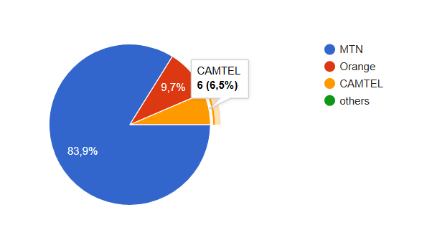MTN dominates the sample at 83.9%, which aligns with its market leadership in Cameroon. Orange and CAMTEL subscribers are represented, providing multi-operator coverage in the dataset.

Operating System
OS | Count | Percentage
Android | 49 | 54.8%
iOS (iPhone) | 41 | 45.2%

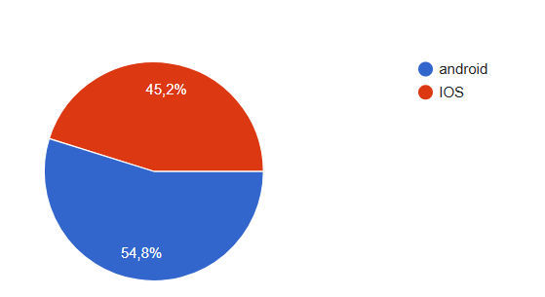

The near-equal split between Android (54.8%) and iOS (45.2%) underscores the need for a cross-platform mobile application. Both platforms must be supported to reach the full target population.

Frequency of Network Problems
Frequency | Count | Percentage | Notes
Always | 15 | 16.1% | Severe persistent issues
Often | 49 | 52.7% | Majority of users
Sometimes | 29 | 31.2% | Occasional disruptions
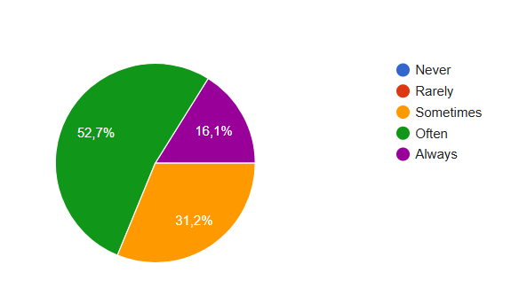
A critical finding: 52.7% of respondents experience network issues either 'often' or 'always'. Combined with 'sometimes' (31.2%), this means 94% of users encounter network problems with non-trivial frequency. This strongly validates the need for the proposed application.

Types of Problems Encountered
Problem Type | Count | Percentage
Slow internet speed | 76 | 81.7%
Poor signal strength | 53 | 57%
Data disconnections | 45 | 48.4%
No network coverage | 20 | 21.5%
Call drops | 20 | 21.5%
High latency / lag | 24 | 25.8%

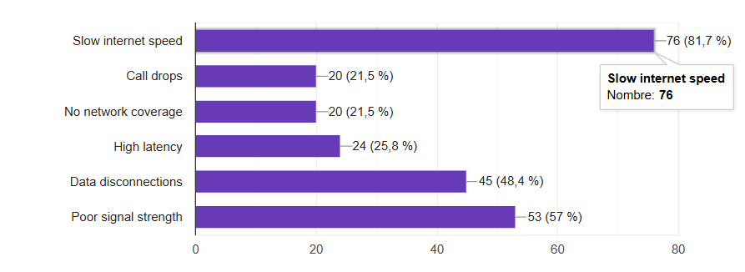
Slow internet speed is by far the most prevalent issue (81.7%), followed by poor signal strength (57%) and data disconnections (45%). These findings directly inform which network metrics the application should prioritize: bandwidth/throughput, signal strength (RSSI/RSRP), and connection stability monitoring.

Willingness to Allow Data Collection
Response | Count | Percentage | Implication
Yes | 27 | 29% | Definite early adopters
Maybe | 60 | 64.5% | Convertible with assurances
No | 6 | 6.5% | Privacy-first refusers

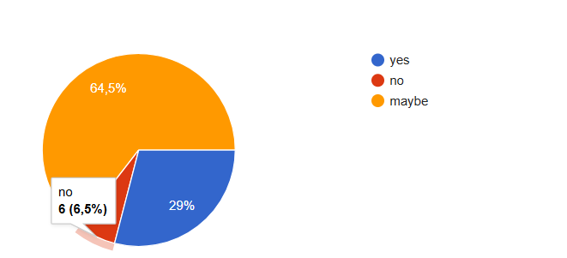
94% of users are either willing or potentially willing to allow data collection. Only 6% flatly refused. This demonstrates strong overall receptivity, provided that appropriate privacy protections and transparency mechanisms are implemented. The 64,5% 'maybe' group represents a key opportunity — their conversion depends on how well the application addresses privacy and data consumption concerns.

User Concerns
Concern | Count | Percentage
Privacy concerns | 64 | 68.8%
Data consumption by the app | 54 | 58.1%
Security risks | 34 | 36.6%
Battery usage impact | 33 | 35.5%
No concerns | 7 | 7.5%

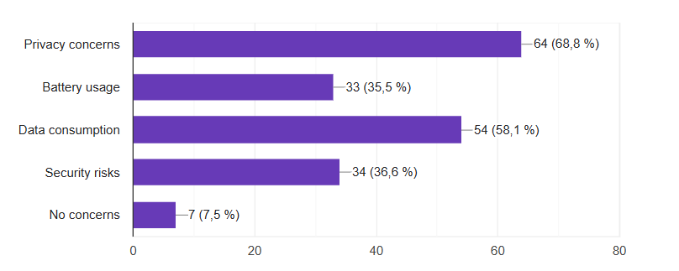
Privacy is the dominant concern at 68.8%, followed closely by data consumption (58.1%), security risks (36.6%), and battery usage (35.5%). These four concerns form the core non-functional requirements for the application:
- Privacy: Transparent consent, anonymization, clear data policies
- Data consumption: Lightweight background collection, data usage reporting within the app
- Security: End-to-end encryption for data transmission, secure server storage
- Battery: Efficient background processing, adaptive collection intervals

2.3.5 Interest in Performance Reports
We receive an overwhelming 82% (74 respondents) expressed interest in seeing reports of their network performance. This supports the inclusion of a personal dashboard and history view as a key motivator for continued app usage and data contribution.

2.4 Brainstorming

2.4.1 Why We Used Brainstorming
After gathering all the information from interviews and surveys, we had a clear picture of the problem. But knowing the problem is not the same as knowing what the system should do about it. Brainstorming was used as the bridge between the data that had been gathered and the actual features the app would need to have.
The goal of the brainstorming sessions was for every member of the team to contribute ideas freely without immediately judging whether an idea was technically possible or not. This approach makes sure that no potentially useful idea is dismissed too early, and it encourages creative thinking about the system's design.

2.4.2 How the Sessions Were Conducted
The team held focused brainstorming sessions where each person shared their thoughts on what the app should do, how it should behave, and what problems it must solve. The team used the survey findings and the partial interview responses as a starting point. Ideas were written down, grouped into categories, and then discussed to decide which ones were feasible and important enough to include.

2.4.3 Ideas Generated
This system is a mobile network monitoring application designed to collect, store, and analyse network performance data while remaining simple for users.

1. Data Collection
The app gathers key network quality metrics such as signal strength (RSRP, SINR, RSSI), internet speed (download/upload), latency (ping), GPS location, and identifies the active operator and network type (2G, 3G, 4G, 5G).

2. User Experience
It provides an easy-to-use interface with an ON/OFF control for data collection, live display of network statistics, WiFi-only upload settings, and alerts when network quality is poor.

3. Data Storage and Privacy
Collected data is first stored locally when offline, then automatically uploaded once internet access is available. All data is anonymized and compressed before transmission to protect privacy and reduce bandwidth use.

4. Backend and Analysis
A REST API backend stores data in a central database and supports map-based visualization, filtering tools for identifying weak coverage areas, and future machine learning models for predicting network quality.

2.5 Reverse Engineering

2.5.1 Why We Used Reverse Engineering
Before designing a new system, it makes sense to look at what already exists. Reverse engineering in this context means studying existing mobile network monitoring applications to understand what features they offer, how they present information to users, and importantly where they fall short. This helps the team avoid reinventing the wheel while also identifying the gaps that the new system should fill.
Existing applications with similar functionalities such as network monitoring tools (e.g., Network Cell Info, OpenSignal, Speedtest by Ookla) were analyzed. This reverse engineering approach helped identify industry best practices in terms of UI design, permission handling, background data collection, and user notification strategies.
Two well-known applications were selected for analysis: OpenSignal and Network Cell Info Lite. Both are widely used for mobile network monitoring and are available on Android devices.

2.5.2 OpenSignal
About the App
OpenSignal is one of the most popular mobile network monitoring apps in the world. It is used by millions of people across many countries and provides visual maps of network coverage based on crowdsourced data from its users. It is available for free on Android and iOS.
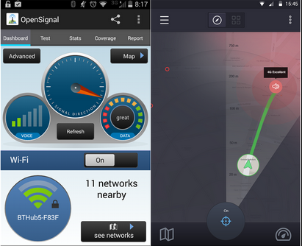
Features Observed
- Shows live signal strength through an easy-to-understand visual display.
- Displays download speed, upload speed, and response time (ping) after completing a speed test.
- Offers a map interface that highlights network coverage performance in various locations using crowdsourced user data.
- Detects and displays the active mobile operator and network technology in use (such as 4G LTE).
- Provides a record of past signal performance over time.
- Compatible with multiple telecom providers and usable across different countries.
Limitations Identified
- Functions poorly in locations without internet access, as data collection is interrupted when connectivity is unavailable
- Lacks offline capability, meaning readings cannot be saved locally for later upload in areas with no signal
- Does not include predictive features to estimate future poor coverage zones
- The user interface may appear complicated and difficult for beginners or non-technical users

2.5.5 What Reverse Engineering Taught Us
Studying these two apps gave the team a very clear picture of what the new system needs to do differently. Both apps have useful features, but neither of them fully solves the problem.
Observation from Reverse Engineering | Requirement for the New System
Both apps collect RSRP, SINR, RSSI these are the standard RF metrics | System must collect RSRP, SINR, and RSSI as core network parameters
OpenSignal uses maps to show coverage users find this helpful | System must include a map-based visualisation of network quality by location
Neither app stores data offline when there is no connection | System must store all data locally first, and upload it when connectivity is available
Neither app predicts or forecasts poor coverage areas | System design should include a foundation for ML-based coverage prediction in future versions
Network Cell Info Lite is too complex for everyday users | App interface must be simple and usable without technical knowledge
OpenSignal's crowdsensing is automatic and not transparent to users | The app must clearly show users when data is being collected and give them the option to stop
No app supports WiFi-only uploads | System must allow users to restrict uploads to WiFi connections only

2.6 Summary of All Requirement Gathering Findings
Using four different techniques gave the team a much more complete picture than any single method could have provided on its own. Each technique contributed something different, and together they produced a solid foundation for defining what the system needs to do.
Technique | What It Contributed | Key Limitation
Surveys (102 users) | Provided quantitative user data; confirmed poor network quality; identified privacy, battery, and control as top concerns; validated crowdsensing feasibility | Self-reported data not technically measured
Brainstorming | Translated findings into a concrete list of features; produced both functional and non-functional requirements; aligned team thinking | Ideas still required validation against technical feasibility
Reverse Engineering | Benchmarked existing solutions; identified standard features to include; exposed gaps that the new system must fill (offline storage, user control, prediction) | Apps studied were designed for general global use, not specifically for Cameroon's network environment

3.Data Gathering

3.1 Overview of the Data Gathering Strategy
Data for this project was collected from two main sources. The first source is primary data, which comes directly from stakeholders through surveys, interviews, and observations. This helped capture real user needs, opinions, and experiences. The second source is secondary data, obtained from research papers, technical reports, and studies of existing crowdsensing platforms. This information supported the system design without the need for extra fieldwork.

The data collection process was planned to be practical and achievable while still producing enough useful information for proper requirement analysis. A mixed-method approach was used, combining qualitative feedback from surveys with technical insights gained from reverse engineering and reviewing similar applications.

Every piece of data collected had a clear purpose and was linked to an actual design decision. The main questions guiding the process included:

Which network parameters should the application measure?
What limits or thresholds should be used to identify coverage holes?
What factors make users willing to use or reject a crowdsensing application?

3.2 Primary Data Sources and Collection Methods
Primary data is first-hand information gathered specifically for this project. Three major stakeholder groups were identified. The table below summarizes the primary data sources, the method used for each, the type of data expected, and the instrument used to collect it.
- Online forms and paper survey

3.2.1 Survey Procedure
The smartphone user survey was distributed using online forms shared via WhatsApp groups and class groups at the University of Buea.
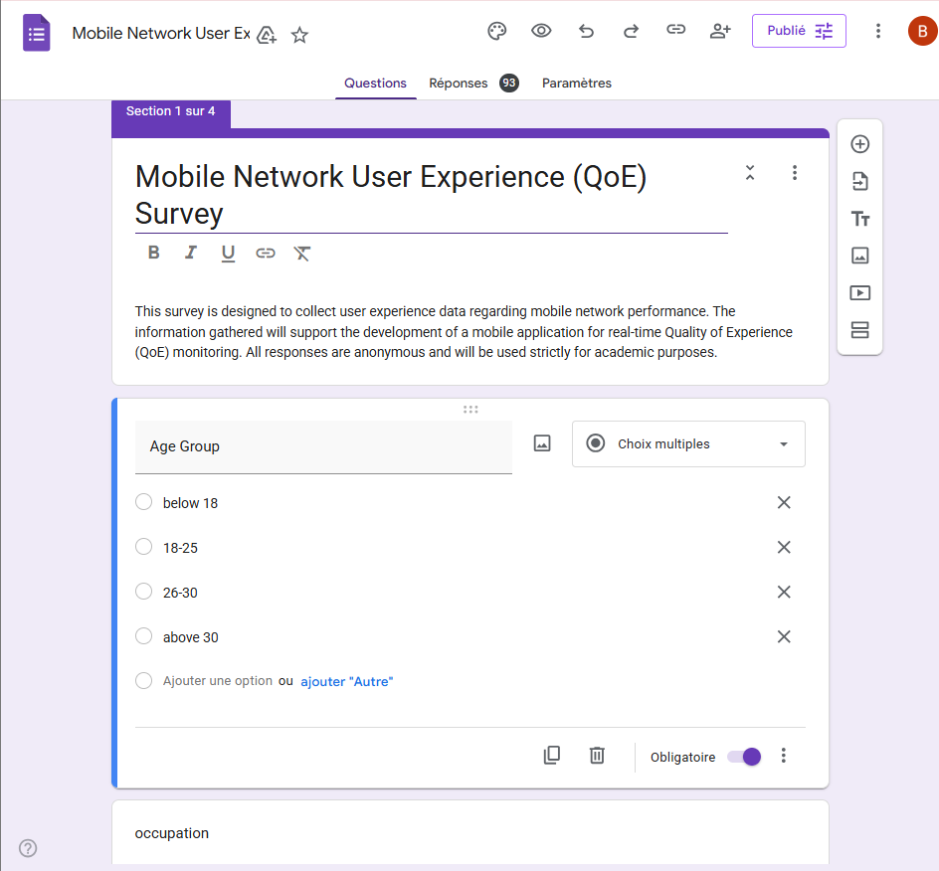

3.2.3 App Analysis
An existing commercial crowdsensing applications, OpenSignal, was installed and tested on Android devices. This hands-on analysis allowed the team to directly observe and document the following:
- What network parameters each app collects.
- How the app presents data to the user.
- What permissions each app requests from the device.
- How the app handles situations with no internet connection.
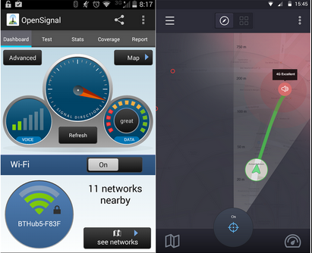

4. DATA CLEANING

4.1 Cleaning Process
The raw survey data underwent a systematic cleaning process prior to analysis. The following steps were applied:

Step 1 – Encoding and Character Artifact Removal
Several responses contained encoding artifacts due to special characters. Specifically, apostrophes and smart quotes in free-text responses were encoded as 'â€™' (UTF-8 misinterpretation). These were identified and corrected. Examples include: "Donâ€™t have any for now" → "Don't have any for now".

Step 2 – Incomplete Response Handling
Two responses had missing values in the 'gender' field and one had a missing 'Would you like to see reports' response. Since these respondents completed all other questions, their records were retained with missing fields treated as non-response rather than excluded.

Step 3 – Normalization of Free-Text Fields
Open-ended suggestion fields contained a range of responses from substantive suggestions to non-responses ("None", "No", "Nope", "None yet", "Not really"). These were classified as 'No suggestion' and excluded from thematic analysis. One dismissive/irrelevant response was also excluded from thematic coding.

Step 4 – Duplicate and Timing Check
Timestamps were reviewed for implausible response patterns. No duplicate submissions were detected. All 90 responses were accepted as valid.

Step 5 – Multi-Select Parsing
Multi-select fields (problems encountered, locations, features desired, etc.) contained semicolon-delimited values. These were parsed and counted individually to enable frequency analysis per category.

4.2 Data Cleaning Summary
Issue | Count | Action Taken
Encoding artifacts (smart quote errors) | ~15 instances | Corrected to proper apostrophes
Missing gender field | 2 responses | Retained; field marked as missing
Non-substantive suggestions | ~30 responses | Excluded from thematic analysis
Invalid/dismissive responses | 1 response | Excluded from suggestion analysis
Duplicate submissions | 0 | No action required

5. USER ASSESSMENT AND USER RELUCTANCE

5.1 User Assessment
User assessment is the process of evaluating what users need, how they behave, what they prefer, and what feedback they give. The goal is to use that information to guide the design and improvement of the mobile application. It involves collecting data from users, understanding what they expect and where they struggle, testing how usable the app is, and measuring how satisfied they are with it.
For this project, user assessment helps the team understand what real smartphone users in Cameroon actually want from a network monitoring app, and what would make them comfortable using it.

5.2 User Reluctance
User reluctance refers to resistance to adopting or using the proposed application, which could limit both the volume and representativeness of collected QoE data. This section analyzes the nature, extent, and implications of user reluctance based on survey responses.

5.2.1 Key Causes of User Reluctance
- Privacy and data security concerns
- Share location
- Provide periodic feedback
- Allow data collection

Indicator | Reluctant Users | Percentage
Unwilling to allow data collection ('No') | 12 | 13%
Unwilling to share location ('No') | 18 | 34%
Unwilling to provide periodic feedback ('No') | 11 | 11.8%
Privacy concerns cited | 64 | 68.8%
Security risks cited | 34 | 36.6%

5.3 List of User Concerns
Based on the survey responses and general research into user behaviour with mobile apps, the following concerns were identified as the most common reasons users hesitate or refuse to use an app like this:
- Privacy and data security concerns
- Unwilling to share location
- Unwilling to provide periodic feedback
- Unwilling to allow data collection
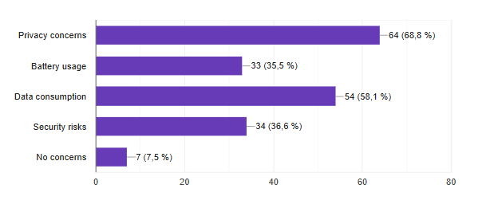
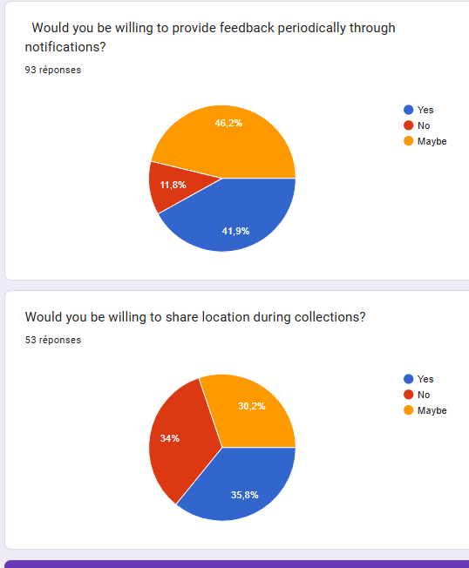

5.4 Primary Reluctance Drivers

5.4.1 Privacy Concerns (68.8%)
Privacy is the leading reluctance driver. Users are worried about how their personal data — especially location and network usage patterns — will be used, stored, and potentially shared with third parties. This concern is amplified by general distrust in data handling practices by app developers.
Mitigation strategy: Implement explicit, granular consent at app onboarding. Provide a clear, plain-language privacy policy. Adopt local data anonymization before transmission and give users access to their own data logs.

5.4.2 Data Consumption (58.1%)
Many users on limited mobile data plans are concerned that the monitoring application will itself consume significant data. Given the economic context of Cameroon where mobile data can be expensive relative to income, this is a significant barrier.
Mitigation strategy: Minimize data transmission overhead by using compressed formats, batching uploads, and allowing Wi-Fi-only sync options. Display the app's own data consumption transparently within the interface.

5.4.3 Security Risks (36.6%)
Users fear that the application could expose their device or personal information to security threats, including unauthorized access to network data or interception of transmitted metrics.
Mitigation strategy: Use HTTPS/TLS for all data transmission. Store minimal identifying information. Conduct security audits and communicate security measures clearly to users.

5.4.4 Battery Usage (35.5%)
Background applications that continuously monitor device and network parameters are known to drain battery. In environments where charging may be intermittent, this is a practical concern.
Mitigation strategy: Implement adaptive polling intervals (reducing frequency when the device is on low battery or the network is stable). Use efficient background service architectures (WorkManager on Android, Background Tasks on iOS).

5.5 Reluctance Severity Assessment
Reluctance Level | Criteria | Estimated User %
High reluctance (hard refusers) | Refused data collection AND cited multiple concerns | ~10–13%
Moderate reluctance | Said 'maybe'; concerned but open to persuasion | ~40–48%
Low reluctance / willing | Said 'yes' to collection with no or minor concerns | ~39–45%

The hard-refuser segment (~10–13%) is unlikely to be converted and should be respected by making app participation entirely voluntary with clear opt-out mechanisms. The moderate group (~45%) is the primary target for trust-building through design transparency and privacy-first architecture.

5.6 Recommendations to Reduce Reluctance
- Implement a clear, interactive onboarding experience that explains what data is collected, why, and how it is used.
- Provide granular permission controls: users can enable/disable location sharing, notification frequency, and data collection categories independently.
- Show users their own collected data in a personal dashboard — this demonstrates transparency and provides personal value.
- Publish a concise privacy policy accessible from within the app at any time.
- Use anonymization techniques (e.g., remove device identifiers, generalize location to district level) to address privacy fears.
- Include a visible 'data used by this app today' counter to address data consumption concerns.

5.7 Summary
User reluctance is one of the biggest practical challenges for any crowdsensing application. If users do not feel comfortable, they will not participate, and the entire data collection system falls apart.
This section identified nine key concerns that users have, explained the reasons behind each one, and proposed concrete solutions that are built directly into the app's requirements. The solutions cover consent, anonymity, user control, performance, and data efficiency.
The questionnaire results confirm that most users are willing to participate if the right conditions are met. The app must make those conditions very clear from the start. Privacy, battery life, and user control are not optional extras. They are core requirements that the system must get right.

6. Derived Requirements

6.1 Functional Requirements

Requirement | Source / Rationale
The app shall run as a background service continuously collecting network metrics (signal strength, network type, latency, packet loss, bandwidth) | 94% experience issues; need passive monitoring
The app shall display real-time network performance metrics on the main dashboard | 70% requested real-time display
The app shall send push notifications when network quality drops below defined thresholds | 64% requested issue alerts; 52% prefer event-driven triggers
The app shall log timestamped network performance records accessible as history | 33% requested performance history logs
The app shall prompt users for subjective satisfaction ratings when network issues are detected | 51% willing to provide periodic feedback
The app shall collect and display GPS/approximate location data linked to network quality readings (with user consent) | 75% willing to share location with conditions
The app shall display the application's own data consumption to the user | 47% requested data usage monitoring; 54% concerned about data consumption
The app shall support offline operation, queuing collected data for upload when connectivity is restored | Multiple user suggestions; logical requirement given poor coverage areas
The app shall provide a personal dashboard showing weekly/historical network performance summaries | 82% interested in performance reports
The app shall support Android (API 21+) and iOS (iOS 13+) platforms | 49 Android, 41 iOS respondents

6.2 Non-Functional Requirements
Category | Requirement
Privacy | All data transmission shall use TLS 1.2+ encryption. Device identifiers shall be hashed before storage.
Privacy | The app shall obtain explicit informed consent before any data collection begins, with granular per-category permissions.
Performance | Background service battery impact shall not exceed 3% additional drain per hour under normal operation.
Performance | The app's own background data consumption shall not exceed 5 MB per day under standard collection settings.
Usability | The app's main interface shall be navigable by a first-time user without instructions within 3 minutes.
Reliability | The app shall queue data locally and synchronize when connectivity is restored, with zero data loss on connection interruption.
Security | All locally stored data shall be encrypted using AES-256. No raw personal identifiers shall be stored on device.
Compatibility | The app shall support Android 5.0+ and iOS 13.0+, covering all identified user devices.

7. CONCLUSION
The requirement gathering phase has yielded a comprehensive understanding of the target users, their network experiences, and their expectations for a QoE data collection mobile application. The survey of 90 Cameroonian mobile subscribers confirmed:
- There is a widespread and frequent experience of network quality issues (94% of users), validating strong market need for the application.
- Users primarily desire real-time visibility and proactive alerts about their network conditions.
- The dominant platform mix (54% Android, 46% iOS) necessitates a cross-platform development approach.
- Privacy and data consumption are the primary barriers to adoption, requiring a privacy-by-design architecture.
- Intelligent, event-driven notifications (triggered by detected issues) are strongly preferred over fixed-interval prompts.
- Offline functionality and resilience under poor connectivity are essential requirements given the network conditions described.

These findings form a solid empirical foundation for the system design and implementation phases. The derived functional and non-functional requirements provide clear, measurable specifications to guide development. Addressing user concerns proactively especially privacy and data efficiency will be critical to achieving meaningful adoption and high-quality data collection outcomes.

